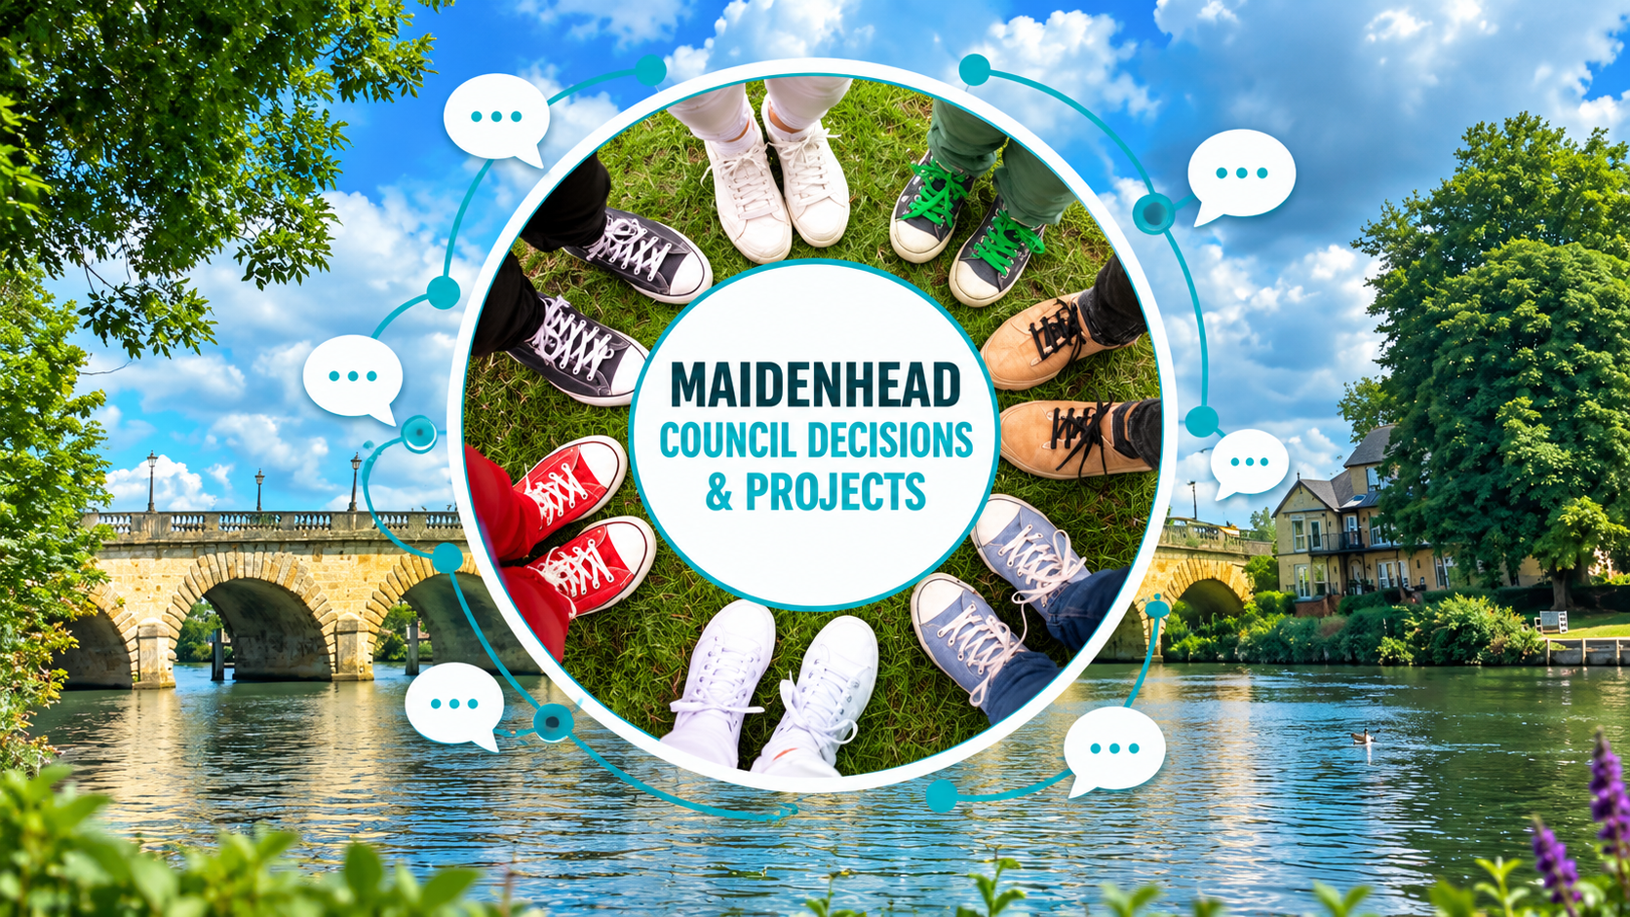

Local issue and blog submission template
Use one copy per topic. Replace the bracketed text and let the boxes expand as you type.
Aim for 400–700 words for a blog or 150–300 words for a short note.

Rough notes are welcome; mark unknown information as unconfirmed.
Article type | [Blog / short note / issue proposal]
Working title | [Specific issue and place]
Contributor and date | [Name, role if relevant, date and version]
Publication details | [Public author name / branch byline; area or ward]
Private contact | [Email for editorial queries — do not publish]

1 Main point
In 2–3 sentences, explain the issue and what you want readers to understand.
[Type your response here]

2 What is happening and why it matters
Where is it happening, who is affected and what is the current position? Separate confirmed facts from your opinion. Suggested 100–150 words.
[Type your response here]

3 Evidence and costs
List the key facts and figures. For every figure, give source reference, date, period covered and whether it is actual, estimated or forecast. Distinguish current spending from proposed costs.
[Fact or figure — source S1 — date — status]
[One-off cost / annual running cost / funding source / unknowns]

4 Who can act
Name the responsible council, organisation or decision-maker and any known decision date.
[Responsible body, decision or deadline; write unknown if not confirmed]

Solutions and publishing details

5 Possible solutions and trade offs
Describe 1–3 realistic options, including the current approach where useful. For each, cover likely benefit, cost or unknowns, disadvantages and who could deliver it. Suggested 100–200 words.
[Option A — benefit — cost — trade off — responsible body]
[Option B — benefit — cost — trade off — responsible body]

6 Preferred next step
State your recommendation and why. Is this a personal suggestion, a proposal for branch discussion or an approved branch position? Do not present a proposal as adopted policy.
[Recommendation, reason and status]
[Reader action or feedback link, if appropriate]

7 Sources
Use S1, S2 and so on in your notes above. Include exact links or attach documents with page numbers. Link to original council papers or published data where available.
[S1 — title — publisher — date — URL or attachment and page]
[S2 — title — publisher — date — URL or attachment and page]

8 Images and attachments
Attach original files separately. Give filename, caption, credit and permission status. Avoid private contact details or unnecessary personal information.
[Filename — caption — credit — permission confirmed or pending]
[Optional main image and alternative text describing it can be pasted here]

Editorial review before publication
Editor to complete. Keep these details off the public page. Verify factual claims and costs, check image permissions and distinguish opinion from fact. Identify anything needing further review.
Checks and questions | [Outstanding checks or corrections; write none if complete]
Decision and approver | [Draft / changes needed / approved] [Approver and date]
Publishing instructions | [Section, proposed publish date and next review date]
Return the completed Word file and image attachments. The website article will use: title, author and date, summary, issue, evidence and costs, possible solutions, next steps and sources. Editorial fields and private contact details stay internal.

